Task 1 — Load the dataset
Task 2 — Data Inspection
Step 1 — Check data types and non-null values
Step 2 — Check missing values
Step 3 — Check duplicate rows
Insight->
Data Quality: The dataset contains 9,994 records and 21 columns. No missing values were found across any column, and no duplicate rows were detected. Numerical columns were correctly recognized by pandas, while Order Date and Ship Date were initially stored as object/string values and require date conversion for time-based analysis.
Task 3 — Overall Business KPIs
Total Sales: 2297200.86
Total Profit: 286397.02
Total Orders: 5009
Total Customers: 793
Profit Margin: 12.47 %
Task 4 — Descriptive Statistics
 | Sales | Quantity | Discount | Profit
count | 9994.000000 | 9994.000000 | 9994.000000 | 9994.000000
mean | 229.858001 | 3.789574 | 0.156203 | 28.656896
std | 623.245101 | 2.225110 | 0.206452 | 234.260108
min | 0.444000 | 1.000000 | 0.000000 | -6599.978000
25% | 17.280000 | 2.000000 | 0.000000 | 1.728750
50% | 54.490000 | 3.000000 | 0.200000 | 8.666500
75% | 209.940000 | 5.000000 | 0.200000 | 29.364000
max | 22638.480000 | 14.000000 | 0.800000 | 8399.976000

Important observations
1. Sales are highly variable
Average sales per row are about 229.86, but the median is only 54.49.
That tells us the dataset has some transactions with very large sales values, which pull the average upward.
For example, the maximum sale is 22,638.48.
2. Quantity
- Average quantity = 3.79
- Median quantity = 3
- Minimum = 1
- Maximum = 14
So most individual records involve relatively small quantities.
3. Discount
- Average discount = 15.62%
- Median discount = 20%
- Minimum = 0%
- Maximum = 80%
4. Profit is highly variable
Average profit is 28.66, while the median is only 8.67.
Most importantly:
Minimum profit = -6,599.98
That means there are individual transactions producing very large losses.
The maximum profit is 8,399.98.
This supports our earlier SQL analysis of loss-making products and customers.
Exploratory Data Analysis:
Descriptive statistics were calculated for Sales, Quantity, Discount, and Profit. Sales showed substantial variation, with a mean of 229.86 and median of 54.49. The average discount was 15.62%, while the maximum discount reached 80%. Profit also showed considerable variation, ranging from a loss of -6,599.98 to a maximum profit of 8,399.98. These results indicate the presence of significant variation in transaction-level sales and profitability.
Task 5 — Category Analysis
Category | Total_Sales | Total_Profit
Furniture | 741999.80 | 18451.27
Office Supplies | 719047.03 | 122490.80
Technology | 836154.03 | 145454.95
Business insight
Technology is the strongest category:
- Highest sales: 836,154.03
- Highest profit: 145,454.95
Furniture needs attention:
- Sales: 741,999.80
- Profit: only 18,451.27
So Furniture generates substantial sales but much less profit than Technology and Office Supplies.
Category Performance Analysis
Category-level analysis showed that Technology generated the highest sales and profit, with total sales of 836,154.03 and total profit of 145,454.95. Furniture generated 741,999.80 in sales but only 18,451.27 in profit, indicating comparatively weak profitability despite significant sales volume.
Task 6 — First Visualization
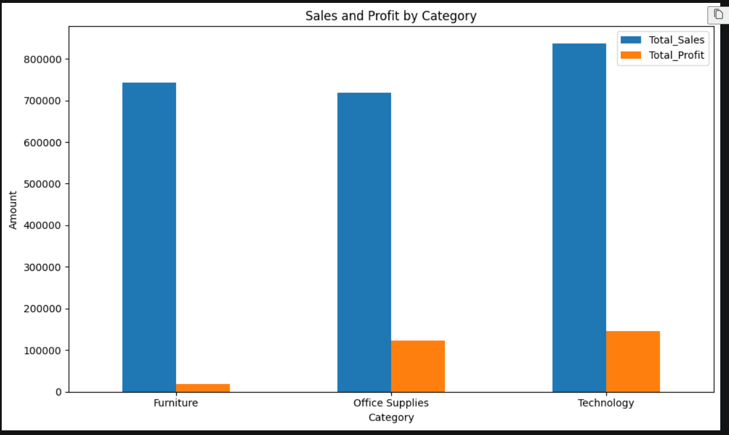
A bar chart was created using Matplotlib to compare sales and profit across product categories. Technology generated the highest sales and profit, while Furniture showed comparatively low profitability despite substantial sales.
Task 7 — Sub-Category Profitability
Sub-Category | Total_Sales | Total_Profit
Tables | 206965.53 | -17725.48
Bookcases | 114880.00 | -3472.56
Supplies | 46673.54 | -1189.10
Fasteners | 3024.28 | 949.52
Machines | 189238.63 | 3384.76
Labels | 12486.31 | 5546.25
Art | 27118.79 | 6527.79
Envelopes | 16476.40 | 6964.18
Furnishings | 91705.16 | 13059.14
Appliances | 107532.16 | 18138.01
Storage | 223843.61 | 21278.83
Chairs | 328449.10 | 26590.17
Binders | 203412.73 | 30221.76
Paper | 78479.21 | 34053.57
Accessories | 167380.32 | 41936.64
Phones | 330007.05 | 44515.73
Copiers | 149528.03 | 55617.82

Key business insights
Loss-making sub-categories:
Sub-Category | Sales | Profit
🔴 Tables | 206,965.53 | -17,725.48
🔴 Bookcases | 114,880.00 | -3,472.56
🔴 Supplies | 46,673.54 | -1,189.10
These three sub-categories are generating sales but losing money.
🟢 Most profitable sub-categories
Sub-Category | Sales | Profit
Copiers | 149,528.03 | 55,617.82
Phones | 330,007.05 | 44,515.73
Accessories | 167,380.32 | 41,936.64
Copiers have the highest total profit.
Sub-Category Profitability Analysis
Sub-category analysis identified Tables, Bookcases, and Supplies as loss-making sub-categories. Tables recorded the largest loss of 17,725.48 despite generating over 206,000 in sales. In contrast, Copiers generated the highest profit at 55,617.82, followed by Phones and Accessories. These results indicate that sales volume alone does not guarantee profitability.
Task 8 — Visualize Sub-Category Profitability
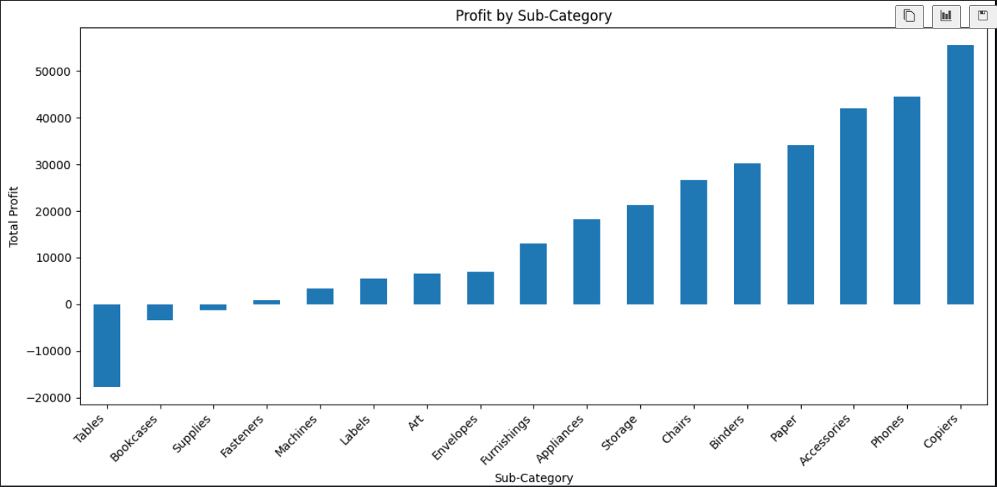
A sub-category profitability bar chart was created using Matplotlib. The visualization clearly highlighted the loss-making sub-categories, particularly Tables, Bookcases, and Supplies, while Copiers, Phones, and Accessories showed strong profitability.

Task 9 — Regional Performance
Region | Total_Sales | Total_Profit
Central | 501239.89 | 39706.36
East | 678781.24 | 91522.78
South | 391721.90 | 46749.43
West | 725457.82 | 108418.45
Business insights
- 🥇 West has the highest sales (725,457.82) and highest profit (108,418.45).
- East is the second strongest region, with 678,781.24 in sales and 91,522.78 profit.
- South has the lowest sales (391,721.90).
- Central has higher sales than South but relatively low profit (39,706.36).
Regional analysis showed that the West region generated the highest sales of 725,457.82 and the highest profit of 108,418.45. The East region ranked second in both sales and profit. The Central region generated substantial sales but comparatively lower profit, indicating an opportunity to investigate regional profitability.
Task 10 — Regional Sales & Profit Visualization
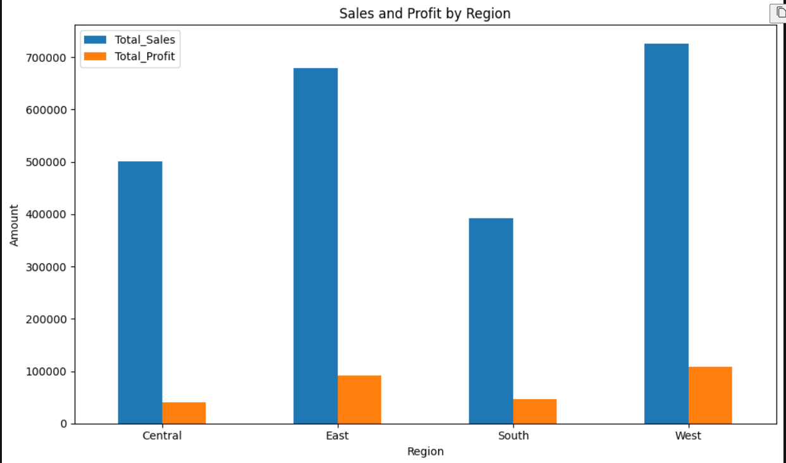
A regional sales and profit bar chart was created using Matplotlib to compare the performance of the four regions. The visualization confirmed that West had the strongest overall performance, while Central showed comparatively lower profit despite generating substantial sales.
Task 11 — Customer Segment Analysis
 | Total_Sales | Total_Profit | Total_Customers
Segment
Consumer | 1161401.34 | 134119.21 | 409
Corporate | 706146.37 | 91979.13 | 236
Home Office | 429653.15 | 60298.68 | 148
Business insights
- 🥇 Consumer is the strongest segment by both sales and profit.
- Consumer customers generated 1.16M sales and 134.12K profit.
- Corporate is the second strongest segment.
- Home Office has the lowest sales and profit among the three segments.
- Consumer also has the largest customer base (409 customers).
Customer segment analysis showed that the Consumer segment was the strongest contributor, generating 1,161,401.34 in sales and 134,119.21 in profit from 409 customers. Corporate ranked second, while Home Office generated the lowest sales and profit. The results indicate that the Consumer segment is the primary customer group and should remain an important focus for sales and retention strategies.
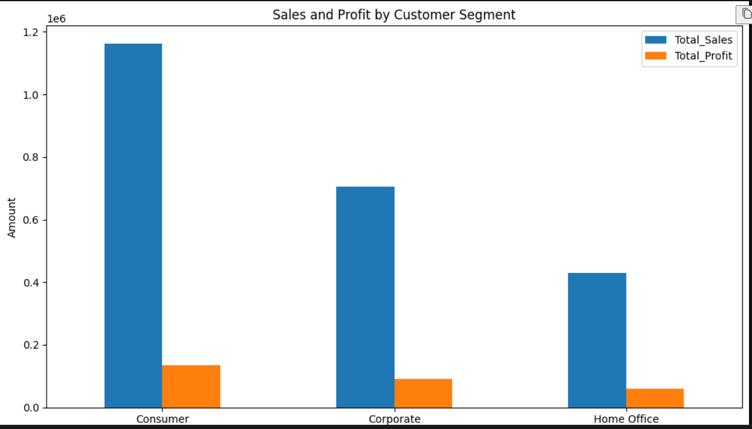
Task 12 — Segment Visualization
A customer segment sales and profit visualization was created using Matplotlib. The chart showed that Consumer is the strongest segment in terms of both sales and profit, followed by Corporate and Home Office.
Task 13 — Top 10 Customers by Sales
Customer Name
Sean Miller 25043.05
Tamara Chand 19052.22
Raymond Buch 15117.34
Tom Ashbrook 14595.62
Adrian Barton 14473.57
Ken Lonsdale 14175.23
Sanjit Chand 14142.33
Hunter Lopez 12873.30
Sanjit Engle 12209.44
Christopher Conant 12129.07
Name: Sales, dtype: float64
Business insight
Sean Miller is the highest-sales customer, generating approximately 25,043 in sales.
The top 10 customers are therefore useful targets for customer retention and relationship management, because losing a high-value customer could have a noticeable impact on sales.
The top 10 customers were identified based on total sales using Python. Sean Miller ranked first with sales of 25,043.05, followed by Tamara Chand and Raymond Buch. These high-value customers represent an important customer group for retention and relationship-building strategies.

Task 14 — Visualize Top 10 Customers
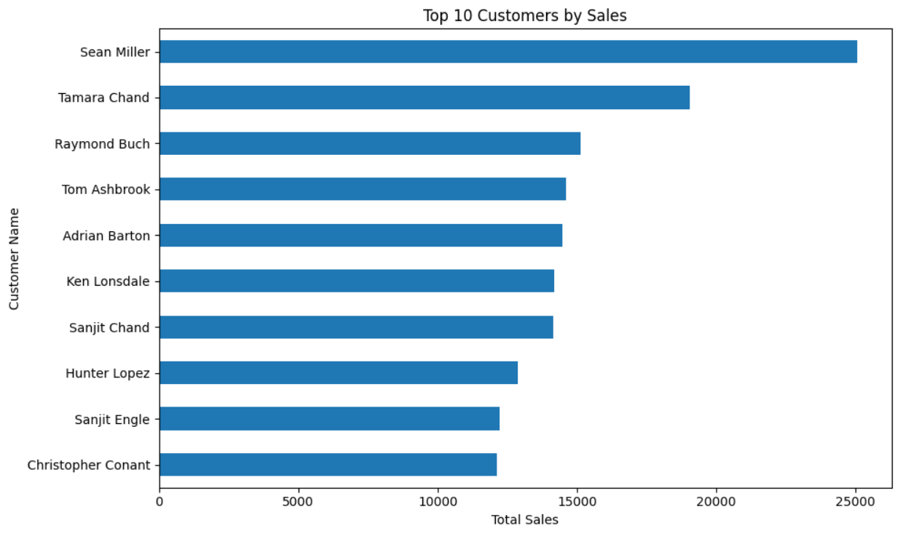
A horizontal bar chart was created to visualize the top 10 customers by sales. The visualization makes it easy to compare high-value customers and highlights Sean Miller as the leading customer by sales.
Task 15 — Top 10 Customers by Profit
Customer Name
Tamara Chand 8981.32
Raymond Buch 6976.10
Sanjit Chand 5757.41
Hunter Lopez 5622.43
Adrian Barton 5444.81
Tom Ashbrook 4703.79
Christopher Martinez 3899.89
Keith Dawkins 3038.63
Andy Reiter 2884.62
Daniel Raglin 2869.08
Name: Profit, dtype: float64
Important business insight
This is a useful comparison with our Top 10 Customers by Sales analysis.
Notice:
- Sean Miller was #1 by sales, but doesn't appear in the top 10 by profit.
- Tamara Chand is #1 by profit.
- This demonstrates an important business point:
A customer generating high sales isn't necessarily the customer generating the highest profit.
That's exactly why we're analyzing both Sales and Profit.
The top 10 customers by profitability were identified using Python. Tamara Chand generated the highest customer profit of 8,981.32, followed by Raymond Buch and Sanjit Chand. Comparison with the sales ranking shows that high sales do not necessarily correspond to high profitability, highlighting the importance of analyzing customer profitability in addition to revenue.
Task 16 — Visualize Top 10 Customers by Profit
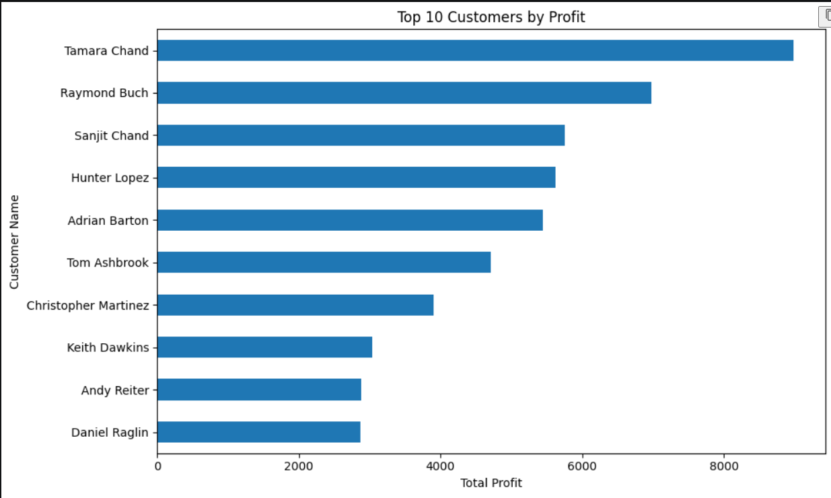
A horizontal bar chart was created to visualize the top 10 customers by profit. The visualization highlights the customers contributing the highest profitability and provides a clear comparison of customer-level profit performance.
Task 17 — Discount & Profitability Analysis
Discount | Total_Sales | Total_Profit
0.00 | 1087908.47 | 320987.60
0.10 | 54369.35 | 9029.18
0.15 | 27558.52 | 1418.99
0.20 | 764594.37 | 90337.31
0.30 | 103226.66 | -10369.28
0.32 | 14493.46 | -2391.14
0.40 | 116417.78 | -23057.05
0.45 | 5484.97 | -2493.11
0.50 | 58918.54 | -20506.43
0.60 | 6644.70 | -5944.66
0.70 | 40620.28 | -40075.36
0.80 | 16963.76 | -30539.04
Important business insight

The relationship between discount and profit is very clear:

0% discount: Profit = 320,987.60
20% discount: Profit = 90,337.31
30% discount: Profit becomes -10,369.28
40% discount: Profit = -23,057.05
70% discount: Profit = -40,075.36
80% discount: Profit = -30,539.04

So, in this dataset, higher discounts are strongly associated with lower profitability.
Discount-level analysis showed a strong relationship between discount and profitability. Transactions with no discount generated the highest total profit of 320,987.60, while higher discount levels resulted in substantial losses. Profit became negative at a 30% discount and remained negative at higher discount levels. This suggests that excessive discounting can significantly reduce or eliminate profitability.
Task 18 — Discount vs Profit Visualization
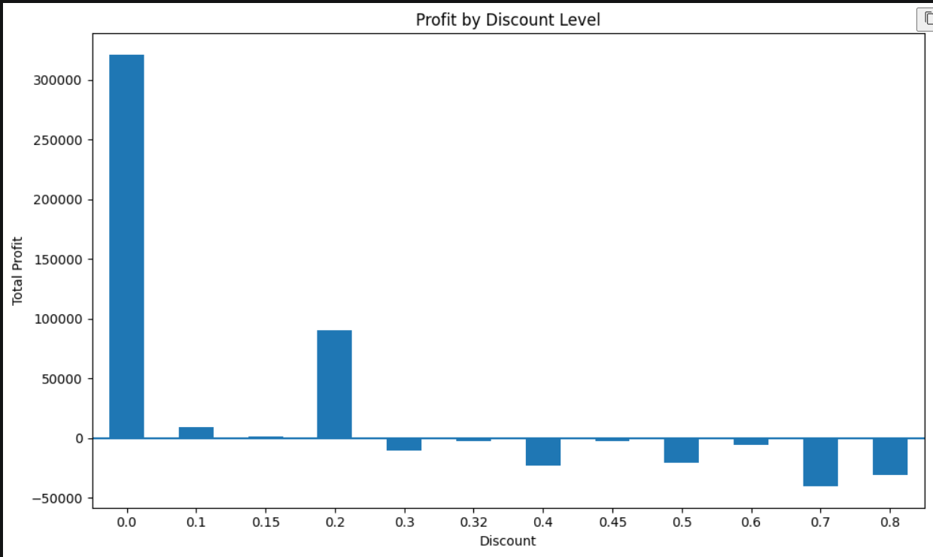
chart shows
- 0% discount → by far the highest profit.
- 10% and 15% → still profitable.
- 20% → profitable, but much lower than 0%.
- 30% and above → the bars go below the zero line, meaning overall losses.
- 70% discount → the largest loss among the discount levels shown.
So the visualization clearly supports our earlier conclusion:
Higher discounts can significantly reduce profitability, and discounts of 30% or more resulted in overall losses in this dataset.
A bar chart was created to visualize total profit across different discount levels. The chart clearly shows that profitability decreases as discount levels increase. Discounts of 30% and above resulted in negative total profit, demonstrating the potential negative impact of excessive discounting on business profitability.
Task 19 — Ship Mode Analysis
Ship Mode | Total_Sales | Total_Profit
First Class | 351428.42 | 48969.84
Same Day | 128363.12 | 15891.76
Second Class | 459193.57 | 57446.64
Standard Class | 1358215.74 | 164088.79
Business insights
- Standard Class generates by far the highest sales and profit.
- Same Day has the lowest sales and profit.
- Standard Class accounts for the largest share of the business's shipping activity.
- However, this analysis shows total performance, not profitability per shipment, so we shouldn't conclude that Standard Class is inherently more profitable per order.
Ship mode analysis showed that Standard Class generated the highest sales of 1,358,215.74 and the highest profit of 164,088.79. Same Day shipping generated the lowest sales and profit. Standard Class therefore represents the primary shipping mode in terms of overall sales and profit contribution.
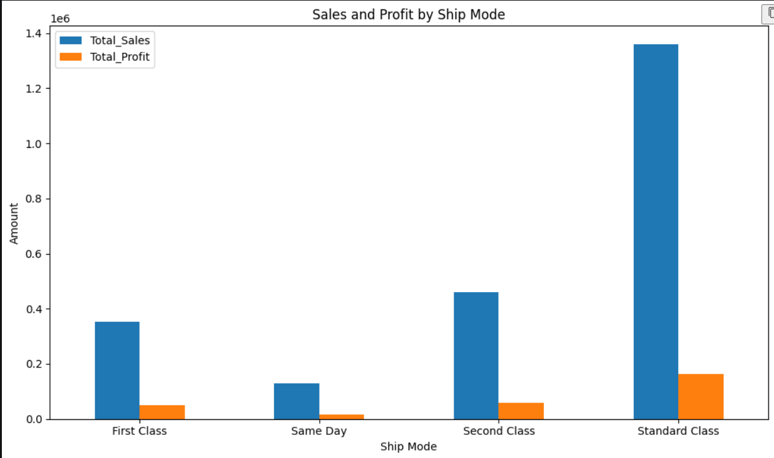

A grouped bar chart was created to compare sales and profit across different shipping modes. Standard Class showed the highest contribution to both sales and profit, while Same Day had the lowest overall contribution.
Task 21 — Monthly Sales Trend
Order Date
2014-01 14236.8950
2014-02 4519.8920
2014-03 55691.0090
2014-04 28295.3450
2014-05 23648.2870
2014-06 34595.1276
2014-07 33946.3930
2014-08 27909.4685
2014-09 81777.3508
2014-10 31453.3930
2014-11 78628.7167
2014-12 69545.6205
2015-01 18174.0756
2015-02 11951.4110
2015-03 38726.2520
2015-04 34195.2085
2015-05 30131.6865
2015-06 24797.2920
2015-07 28765.3250
2015-08 36898.3322
2015-09 64595.9180
2015-10 31404.9235
2015-11 75972.5635
2015-12 74919.5212
...
2017-09 87866.6520
2017-10 77776.9232
2017-11 118447.8250
2017-12 83829.3188
Freq: M, Name: Sales, dtype: float64
- Sales fluctuate considerably from month to month.
- 2017-11 is particularly strong at about 118,447.83.
- 2014-02 is one of the lowest months at about 4,519.89.
- The later years generally show higher monthly sales than the earlier years.
Monthly sales were aggregated using the Order Date to identify sales trends over the 48-month period from January 2014 through December 2017. The analysis showed considerable month-to-month variation, with several strong sales periods occurring in the later years.
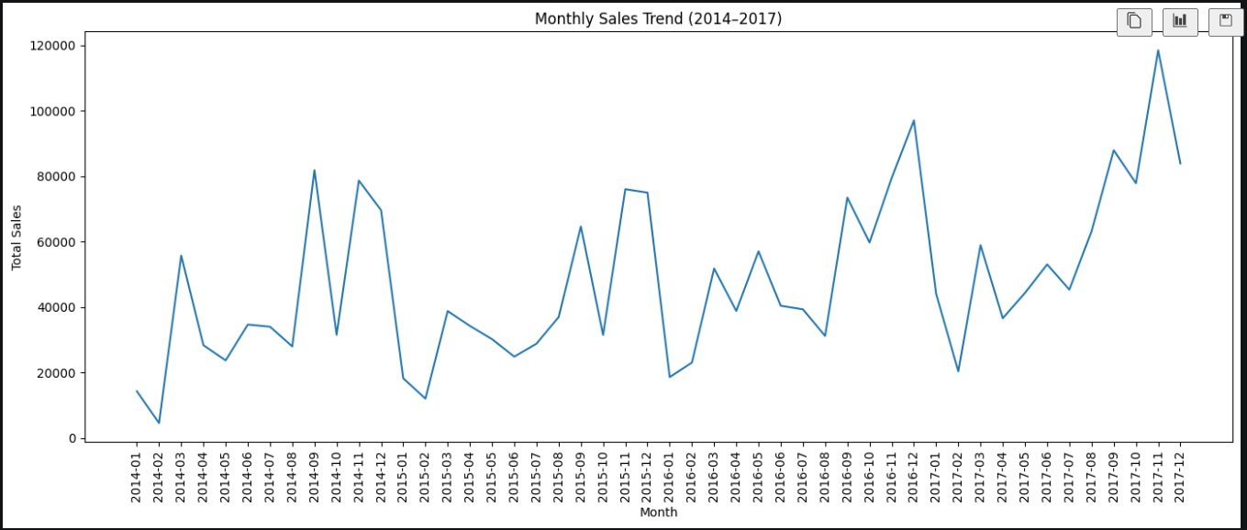
Key insights from the chart
- Sales show strong month-to-month fluctuations rather than a smooth trend.
- November 2017 is the highest month, with sales of approximately 118,447.83.
- February 2014 is the lowest month, with sales of approximately 4,519.89.
- The later part of 2017 shows several strong sales months, especially September, November, and December.
- There are noticeable recurring peaks toward the later months of several years, which may indicate some seasonal purchasing behavior.
A line chart was created to visualize monthly sales from 2014 to 2017. The chart highlights significant month-to-month fluctuations and identifies November 2017 as the strongest sales month. The later years, particularly 2017, show several high-sales periods compared with earlier years.
Task 23 — Yearly Sales & Year-over-Year Growth
Order Date | Total_Sales | YoY_Growth
2014 | 484247.50 | NaN
2015 | 470532.51 | -2.83
2016 | 609205.60 | 29.47
2017 | 733215.26 | 20.36
Business insights
- 2015: Sales decreased slightly by 2.83% compared with 2014.
- 2016: Sales recovered strongly, growing 29.47%.
- 2017: Sales continued to grow by 20.36%, reaching the highest annual sales of the four-year period.
- Overall, the business shows strong growth after 2015.
Year-over-year sales analysis showed a slight decline of 2.83% in 2015, followed by strong growth of 29.47% in 2016 and 20.36% in 2017. The highest annual sales were recorded in 2017 at 733,215.26, indicating strong business growth during the later years.
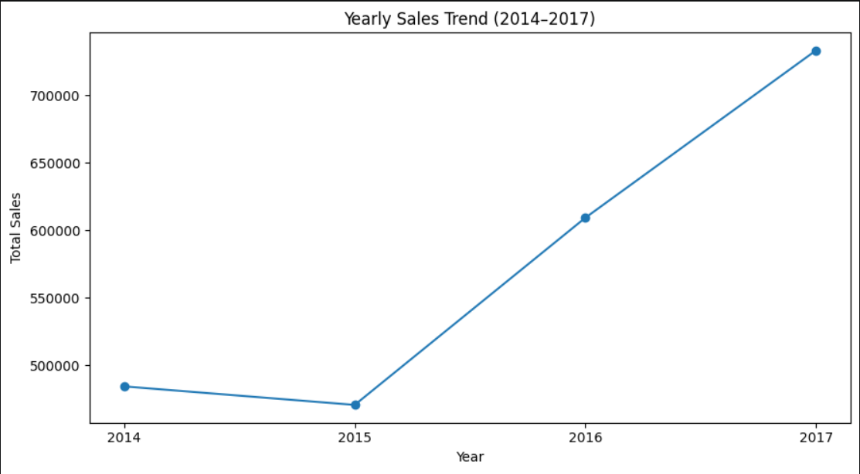
Task 25 — Customer Sales & Profit Analysis
Customer Name | Total_Sales | Total_Profit | Total_Orders
Sean Miller | 25043.05 | -1980.74 | 5
Tamara Chand | 19052.22 | 8981.32 | 5
Raymond Buch | 15117.34 | 6976.10 | 6
Tom Ashbrook | 14595.62 | 4703.79 | 4
Adrian Barton | 14473.57 | 5444.81 | 10
Ken Lonsdale | 14175.23 | 806.86 | 12
Sanjit Chand | 14142.33 | 5757.41 | 9
Hunter Lopez | 12873.30 | 5622.43 | 6
Sanjit Engle | 12209.44 | 2650.68 | 11
Christopher Conant | 12129.07 | 2177.05 | 5
- Tamara Chand has lower sales than Sean Miller but much higher profit.
- Adrian Barton has 10 orders and generates strong profit.
- Ken Lonsdale has the highest number of orders among these 10, but relatively low profit.
Customer-level analysis combined total sales, total profit, and number of orders. The analysis revealed that high sales do not always result in high profitability. Sean Miller ranked first in sales but generated a loss of 1,980.74, while Tamara Chand generated substantially higher profit despite having lower sales. This highlights the importance of evaluating both revenue and profitability at the customer level.
Task 26 — Identify Loss-Making Customers
(155, 3)
Customer Name | Total_Sales | Total_Profit | Total_Orders
Sean Miller | 25043.05 | -1980.74 | 5
Becky Martin | 11789.63 | -1659.96 | 4
Grant Thornton | 9351.21 | -4108.66 | 3
Peter Fuller | 9062.86 | -614.29 | 4
Natalie Fritzler | 8322.83 | -1695.97 | 7
Sean Braxton | 8057.89 | -2082.75 | 7
Zuschuss Carroll | 8025.71 | -1032.15 | 13
Joseph Holt | 7955.00 | -644.70 | 6
Joseph Airdo | 6491.03 | -819.42 | 8
Victoria Wilson | 6134.04 | -874.66 | 10
Business insight
A customer can generate substantial sales but still be unprofitable.
For example, Sean Miller generated over 25K in sales, yet the business incurred a loss of approximately 1,981 on that customer.
This is exactly the type of finding that makes your project stronger than simply showing sales totals.
Customer profitability analysis identified 155 customers with negative total profit. Several customers generated significant sales but still resulted in losses. This indicates that customer revenue alone is not sufficient to measure customer value and that profitability should also be considered when evaluating customer performance.
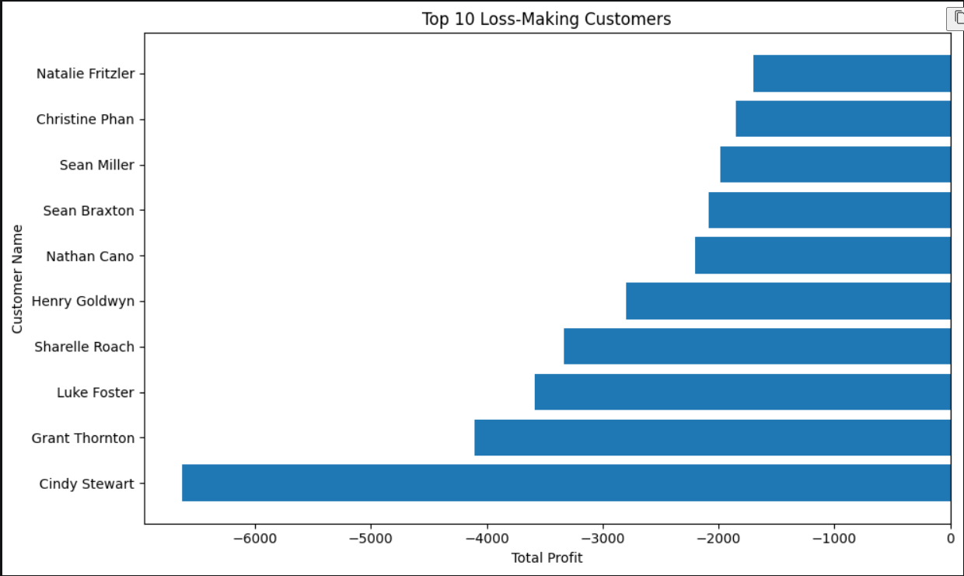
A horizontal bar chart was created to visualize the top 10 loss-making customers. The visualization highlights customers with the largest negative profit and helps identify customers who may require further investigation into discounts, product mix, or order profitability.
Task 28 — Product Performance Analysis
Product Name | Total_Sales | Total_Profit
Canon imageCLASS 2200 Advanced Copier | 61599.82 | 25199.93
Fellowes PB500 Electric Punch Plastic Comb Binding Machine with Manual Bind | 27453.38 | 7753.04
Cisco TelePresence System EX90 Videoconferencing Unit | 22638.48 | -1811.08
HON 5400 Series Task Chairs for Big and Tall | 21870.58 | 0.00
GBC DocuBind TL300 Electric Binding System | 19823.48 | 2233.51
GBC Ibimaster 500 Manual ProClick Binding System | 19024.50 | 760.98
Hewlett Packard LaserJet 3310 Copier | 18839.69 | 6983.88
HP Designjet T520 Inkjet Large Format Printer - 24" Color | 18374.90 | 4094.98
GBC DocuBind P400 Electric Binding System | 17965.07 | -1878.17
High Speed Automatic Electric Letter Opener | 17030.31 | -262.00
Important business insight
Again, we're seeing the same pattern from the customer analysis:
High sales do not automatically mean high profit.
For example:
- Cisco TelePresence System EX90 generated 22,638.48 sales, but resulted in a 1,811.08 loss.
- GBC DocuBind P400 generated 17,965.07 sales, but resulted in a 1,878.17 loss.
- Meanwhile, the Canon imageCLASS 2200 Advanced Copier generated both very high sales and very high profit.
This is a strong finding for your project because it identifies products that may need pricing, discount, or cost analysis.
Product-level analysis identified the top 10 products by sales and compared their corresponding profitability. The Canon imageCLASS 2200 Advanced Copier generated the highest sales of 61,599.82 and a profit of 25,199.93. However, some high-sales products generated negative or zero profit, demonstrating that product revenue alone does not determine product performance.
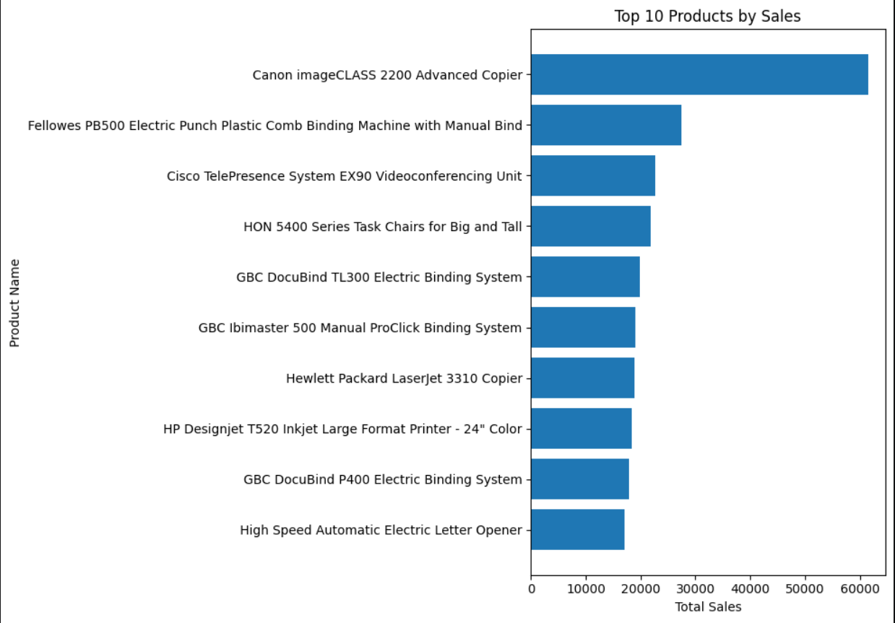
A horizontal bar chart was created to visualize the top 10 products by sales. The visualization makes it easy to compare product sales performance and highlights the Canon imageCLASS 2200 Advanced Copier as the leading product.
Task 30 — Top 10 Products by Profit
Product Name | Total_Sales | Total_Profit
Zebra ZM400 Thermal Label Printer | 6965.70 | 3343.54
Ibico EPK-21 Electric Binding System | 15875.92 | 3345.28
Plantronics Savi W720 Multi-Device Wireless Headset System | 9367.29 | 3696.28
3D Systems Cube Printer, 2nd Generation, Magenta | 14299.89 | 3717.97
Ativa V4110MDD Micro-Cut Shredder | 7699.89 | 3772.95
HP Designjet T520 Inkjet Large Format Printer - 24" Color | 18374.90 | 4094.98
Canon PC1060 Personal Laser Copier | 11619.83 | 4570.93
Hewlett Packard LaserJet 3310 Copier | 18839.69 | 6983.88
Fellowes PB500 Electric Punch Plastic Comb Binding Machine with Manual Bind | 27453.38 | 7753.04
Canon imageCLASS 2200 Advanced Copier | 61599.82 | 25199.93
Business insight
The Canon imageCLASS 2200 Advanced Copier is the standout product:
- Highest sales: 61,599.82
- Highest profit: 25,199.93
- It is therefore strong in both revenue and profitability.
Notice that this ranking is different from simply ranking products by sales. That's important because it shows why your project should analyze both Sales and Profit.
The top 10 products by total profit were identified using Python. The Canon imageCLASS 2200 Advanced Copier generated the highest profit of 25,199.93, followed by the Fellowes PB500 Electric Punch and Hewlett Packard LaserJet 3310 Copier. The analysis demonstrates that product profitability provides additional insight beyond sales performance.
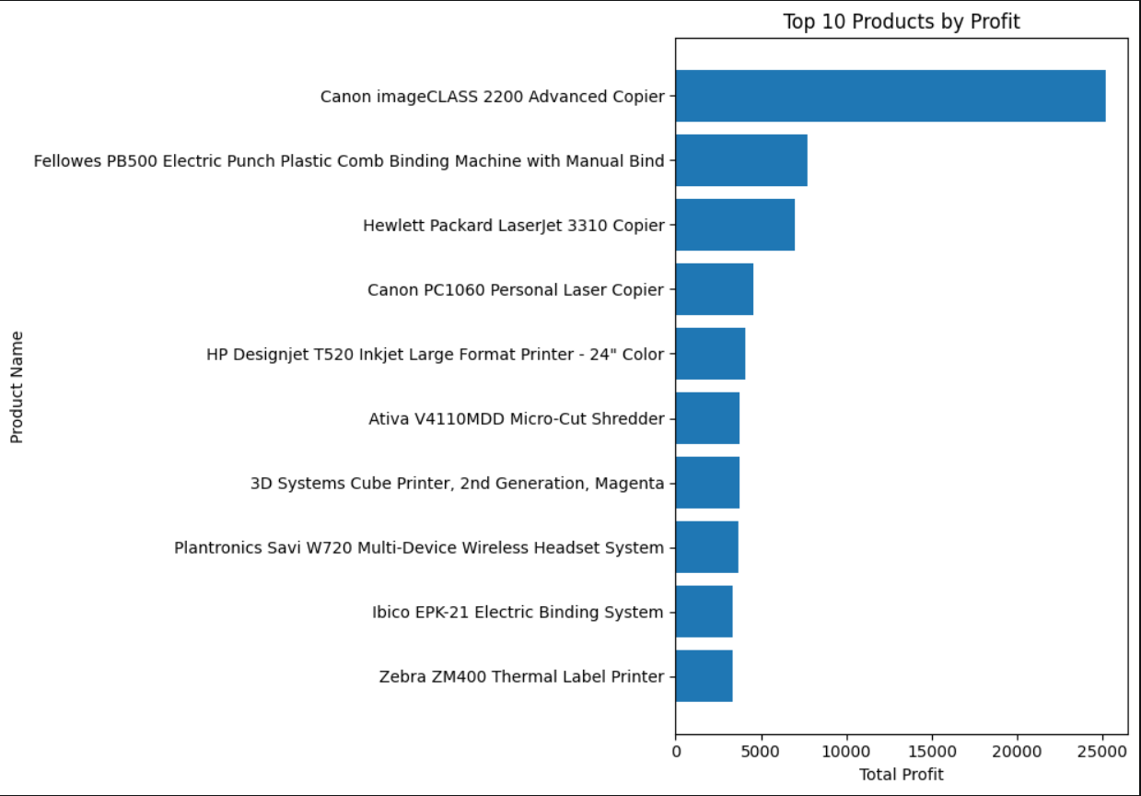
A horizontal bar chart was created to visualize the top 10 products by profit. The visualization clearly compares product profitability and highlights the Canon imageCLASS 2200 Advanced Copier as the most profitable product.
Task 32 — Regional Customer Analysis
 | Region | Customer Name | Total_Sales | Sales_Rank
579 | Central | Tamara Chand | 18437.138 | 1.0
5 | Central | Adrian Barton | 12181.594 | 2.0
57 | Central | Becky Martin | 10539.896 | 3.0
1276 | East | Tom Ashbrook | 13723.498 | 1.0
916 | East | Hunter Lopez | 10522.550 | 2.0
705 | East | Bill Shonely | 10022.293 | 3.0
1745 | South | Sean Miller | 23669.196 | 1.0
1736 | South | Sanjit Engle | 8805.040 | 2.0
1499 | South | Grant Thornton | 8167.420 | 3.0
2354 | West | Raymond Buch | 14345.276 | 1.0
2199 | West | Ken Lonsdale | 8472.394 | 2.0
2029 | West | Edward Hooks | 7447.770 | 3.0
Business insights
- Sean Miller is the strongest regional customer, with 23,669.20 in South-region sales.
- Tamara Chand leads the Central region.
- Tom Ashbrook leads the East region.
- Raymond Buch leads the West region.
- The gap between the #1 customer and the other top customers is particularly large in the South and West regions.
This is useful for identifying high-value customers within individual geographic markets.
Regional customer analysis identified the top three customers by sales within each region. Tamara Chand led the Central region, Tom Ashbrook led the East, Sean Miller led the South, and Raymond Buch led the West. The analysis helps identify high-value customers within each geographic market.
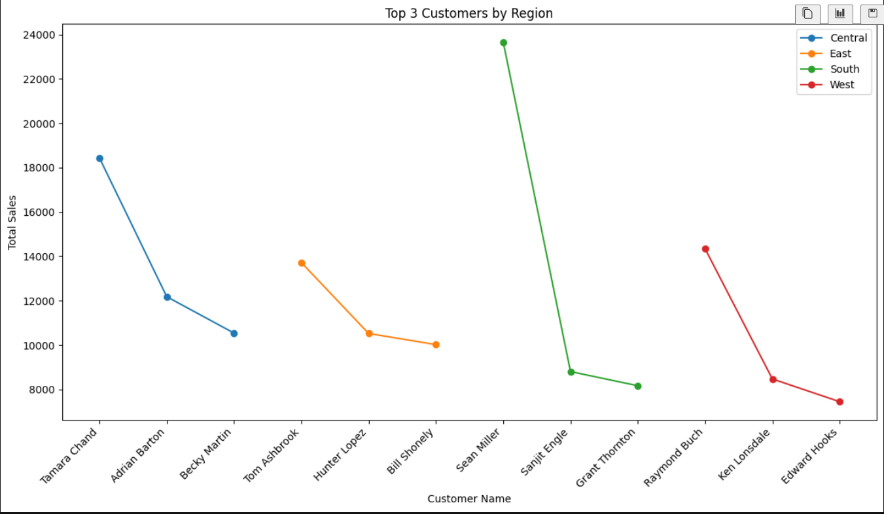
A visualization was created to compare the top three customers by sales across the four regions. The chart provides a regional view of high-value customers and helps identify differences in customer sales performance across geographic markets.
Task 34 — Profit Margin by Region
Region | Total_Sales | Total_Profit | Profit_Margin
Central | 501239.89 | 39706.36 | 7.92
East | 678781.24 | 91522.78 | 13.48
South | 391721.90 | 46749.43 | 11.93
West | 725457.82 | 108418.45 | 14.94
Business insights
- 🥇 West has the highest profit margin at 14.94%.
- East is second at 13.48%.
- South has an 11.93% margin.
- ⚠️ Central has the lowest margin at only 7.92%, despite generating over 501K in sales.
This is a particularly valuable finding: Central has significant sales but relatively weak profitability, so it deserves further investigation into discounts, product mix, and loss-making products.
Profit margin analysis showed that the West region had the highest profitability at 14.94%, followed by East at 13.48% and South at 11.93%. Central had the lowest profit margin at 7.92% despite generating more than 501,000 in sales. This indicates an opportunity to investigate the factors affecting profitability in the Central region.
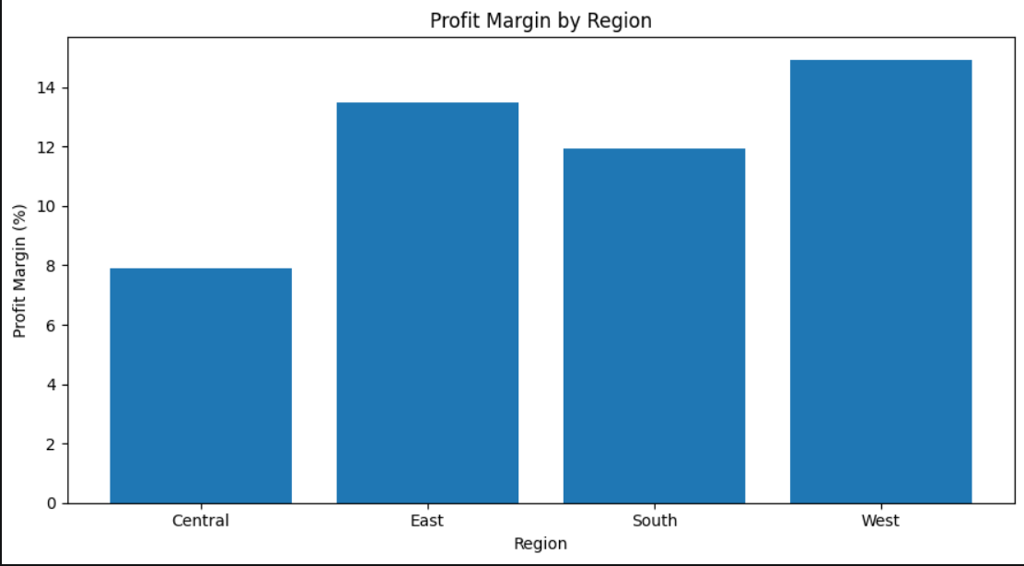
A bar chart was created to visualize profit margins across the four regions. The visualization clearly shows that the West region has the highest profit margin, while Central has the lowest. This makes regional profitability differences easy to compare.
Task 36 — Category Profitability Analysis
Category | Total_Sales | Total_Profit | Profit_Margin
Furniture | 741999.80 | 18451.27 | 2.49
Office Supplies | 719047.03 | 122490.80 | 17.04
Technology | 836154.03 | 145454.95 | 17.40
Business insights
- 🥇 Technology is the strongest category, with the highest sales, profit, and profit margin.
- Office Supplies also performs strongly, with a 17.04% margin.
- ⚠️ Furniture is the major concern: although it generates 741,999.80 in sales, its profit is only 18,451.27, giving it a very low 2.49% margin.
- This suggests that Furniture needs further investigation, especially its sub-categories such as Tables and Bookcases, which we already found to be loss-making.
Category-level profitability analysis showed that Technology generated the highest sales and profit, with a profit margin of 17.40%. Office Supplies also performed strongly with a 17.04% margin. Furniture generated substantial sales but had a significantly lower profit margin of only 2.49%, indicating a potential profitability issue within the category.
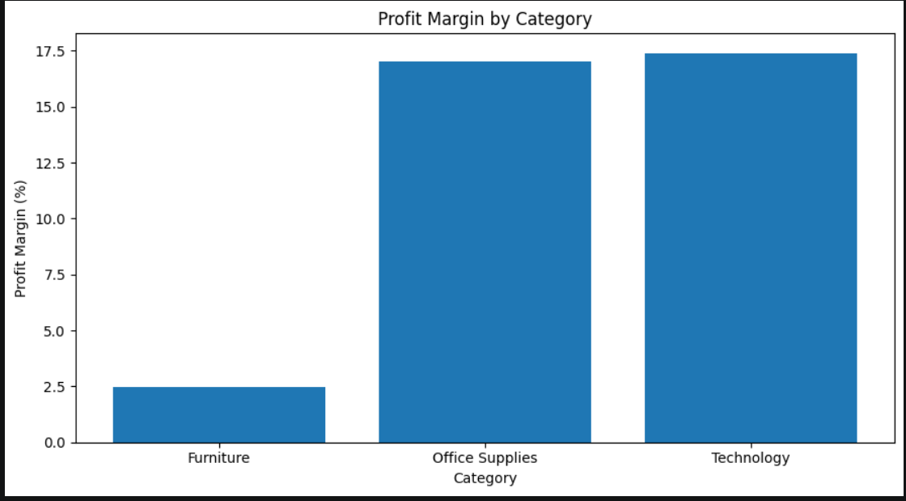
- Technology: 17.40% — highest
- Office Supplies: 17.04%
- Furniture: 2.49% — much lower
A bar chart was created to visualize profit margins by category. Technology and Office Supplies show strong profitability, while Furniture has a substantially lower profit margin. The visualization highlights Furniture as a category requiring further profitability analysis.
Task 38 — Sub-Category Profitability Analysis
Total_Sales | Total_Sales | Total_Profit | Profit_Margin
Tables | 206965.53 | -17725.48 | -8.56
Bookcases | 114880.00 | -3472.56 | -3.02
Supplies | 46673.54 | -1189.10 | -2.55
Fasteners | 3024.28 | 949.52 | 31.40
Machines | 189238.63 | 3384.76 | 1.79
Labels | 12486.31 | 5546.25 | 44.42
Art | 27118.79 | 6527.79 | 24.07
Envelopes | 16476.40 | 6964.18 | 42.27
Furnishings | 91705.16 | 13059.14 | 14.24
Appliances | 107532.16 | 18138.01 | 16.87
Storage | 223843.61 | 21278.83 | 9.51
Chairs | 328449.10 | 26590.17 | 8.10
Binders | 203412.73 | 30221.76 | 14.86
Paper | 78479.21 | 34053.57 | 43.39
Accessories | 167380.32 | 41936.64 | 25.05
Phones | 330007.05 | 44515.73 | 13.49
Copiers | 149528.03 | 55617.82 | 37.20
Most important insight
Tables are the biggest profitability problem.
They generated:
- $206,965.53 in sales
- -$17,725.48 in profit
- -8.56% profit margin
So the company is generating substantial revenue from Tables but actually losing money.
On the other hand, Labels have a 44.42% margin, and Paper has a 43.39% margin.
Sub-category profitability analysis identified significant differences in performance. Tables had the lowest profitability, generating a loss of 17,725.48 and a negative profit margin of 8.56%. Bookcases and Supplies also generated negative profits. In contrast, Labels, Paper, Envelopes, and Copiers showed strong profit margins. This analysis helps identify sub-categories requiring corrective action and those contributing strongly to overall profitability.
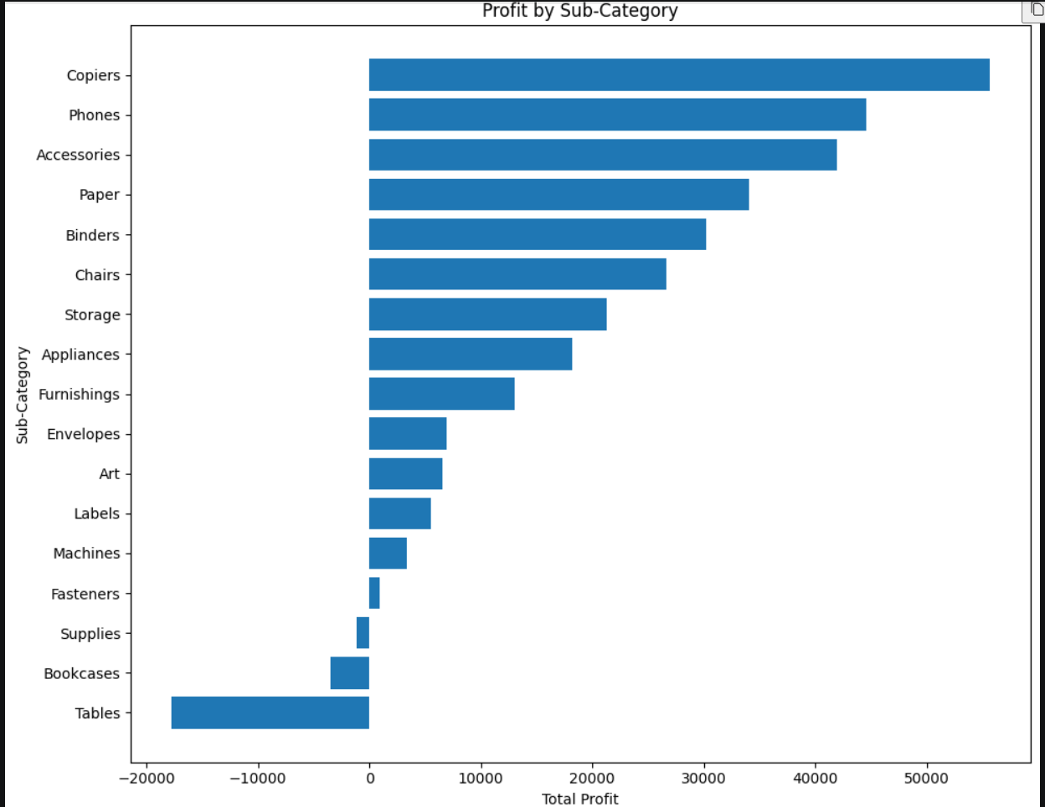
What the chart shows
- 🏆 Copiers have the highest profit at about 55,618.
- Phones are second at about 44,516.
- Accessories generate about 41,937.
- Tables are the biggest loss-maker at about -17,725.
- Bookcases and Supplies also show negative profit.
- The chart makes the profitability gap between sub-categories very easy to see.
A horizontal bar chart was created to visualize profit by sub-category. The chart highlights Copiers, Phones, and Accessories as major contributors to profit, while Tables, Bookcases, and Supplies generate negative profits. This visualization helps identify both high-performing and loss-making sub-categories.
Python — Final Analysis 1: Correlation Analysis
Step 1 — Calculate correlations
 | Sales | Quantity | Discount | Profit
Sales | 1.00 | 0.20 | -0.03 | 0.48
Quantity | 0.20 | 1.00 | 0.01 | 0.07
Discount | -0.03 | 0.01 | 1.00 | -0.22
Profit | 0.48 | 0.07 | -0.22 | 1.00
Step 2 — Visualize it
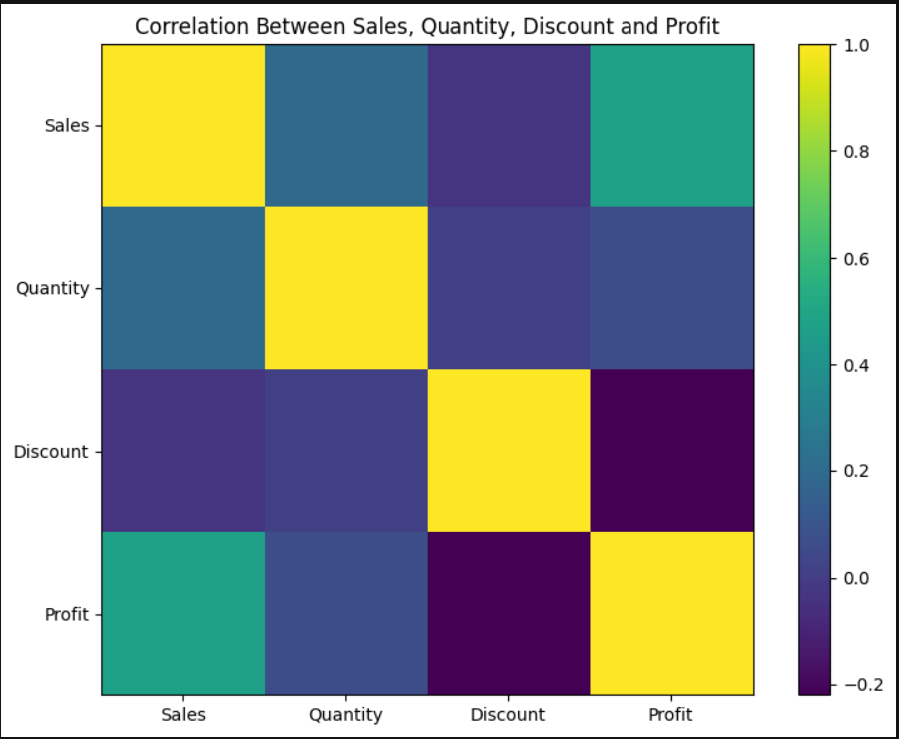
- Sales ↔ Profit: 0.48 → moderate positive relationship.
- Discount ↔ Profit: -0.22 → negative relationship; higher discounts tend to be associated with lower profit.
- Sales ↔ Quantity: 0.20 → weak positive relationship.
- Quantity ↔ Profit: 0.07 → very weak relationship.
- Discount ↔ Sales: -0.03 → almost no linear relationship.
- Discount ↔ Quantity: 0.01 → essentially no linear relationship.
Correlation analysis showed a moderate positive relationship between Sales and Profit (0.48). Discount had a negative relationship with Profit (-0.22), supporting the earlier finding that higher discounts can negatively affect profitability. Quantity showed only a weak relationship with Profit (0.07).
Final Python analysis: loss-making customers
Customer Name | Total_Sales | Total_Profit | Total_Orders
Cindy Stewart | 5690.05 | -6626.39 | 6
Grant Thornton | 9351.21 | -4108.66 | 3
Luke Foster | 3930.51 | -3583.98 | 7
Sharelle Roach | 3233.48 | -3333.91 | 5
Henry Goldwyn | 3247.64 | -2797.96 | 12
... | ... | ... | ...
Thais Sissman | 4.83 | -3.32 | 2
Adrian Hane | 1735.51 | -2.31 | 7
Mitch Gastineau | 16.74 | -1.25 | 1
Paul Lucas | 239.48 | -0.75 | 5
Jasper Cacioppo | 71.26 | -0.36 | 4
155 rows × 3 columns
len(loss_making_customers)
155
customer-level analysis with unique orders:
 | Customer ID | Customer_Name | Total_Sales | Total_Profit | Total_Orders | Profit_Margin
0 | AA-10315 | Alex Avila | 5563.560 | -362.8825 | 5 | -0.065225
1 | AA-10375 | Allen Armold | 1056.390 | 277.3824 | 9 | 0.262576
2 | AA-10480 | Andrew Allen | 1790.512 | 435.8274 | 4 | 0.243409
3 | AA-10645 | Anna Andreadi | 5086.935 | 857.8033 | 6 | 0.168629
4 | AB-10015 | Aaron Bergman | 886.156 | 129.3465 | 3 | 0.145964
5 | AB-10060 | Adam Bellavance | 7755.620 | 2054.5885 | 8 | 0.264916
6 | AB-10105 | Adrian Barton | 14473.571 | 5444.8055 | 10 | 0.376190
7 | AB-10150 | Aimee Bixby | 966.710 | 313.6597 | 5 | 0.324461
8 | AB-10165 | Alan Barnes | 1113.838 | 220.8130 | 8 | 0.198245
9 | AB-10255 | Alejandro Ballentine | 914.532 | 264.5675 | 9 | 0.289293
Step 4 — Identify high-value but loss-making customers
Customer ID | Customer_Name | Total_Sales | Total_Profit | Total_Orders | Profit_Margin
180 | CS-12505 | Cindy Stewart | 5690.055 | -6626.3895 | 6 | -1.164556
310 | GT-14635 | Grant Thornton | 9351.212 | -4108.6589 | 3 | -0.439372
459 | LF-17185 | Luke Foster | 3930.509 | -3583.9770 | 7 | -0.911835
666 | SB-20290 | Sean Braxton | 8057.891 | -2082.7451 | 7 | -0.258473
700 | SM-20320 | Sean Miller | 25043.050 | -1980.7393 | 5 | -0.079093
165 | CP-12340 | Christine Phan | 5888.275 | -1850.3029 | 8 | -0.314235
560 | NF-18385 | Natalie Fritzler | 8322.826 | -1695.9714 | 7 | -0.203774
90 | BM-11140 | Becky Martin | 11789.630 | -1659.9581 | 4 | -0.140798
738 | TB-21520 | Tracy Blumstein | 4737.486 | -1603.0451 | 9 | -0.338375
651 | RO-19780 | Rose O'Brian | 3815.478 | -1262.5716 | 7 | -0.330908

Customer Segmentation
Customer_Segment
Profitable High Value 329
Low Value Profitable 309
Low Value Loss-Making 87
High Value Loss-Making 68
Name: count, dtype: int64
68 High Value Loss-Making customers
These customers generate relatively high sales but have negative profit. They should be investigated for things like high discounts, low-margin products, or unprofitable orders.
And this is exactly where your project becomes Customer Intelligence, rather than just sales reporting.
Analysis between discount and profit for the entire dataset:
 | Discount | Profit
Discount | 1.000000 | -0.219487
Profit | -0.219487 | 1.000000
What the result means
Your correlation between Discount and Profit is -0.219487.
That means:
- The relationship is negative.
- As discount increases, profit tends to decrease.
- The relationship is weak to moderate, not extremely strong.
- It does not prove that discount causes lower profit; it only shows an association in this dataset.
So your project can state:
Higher discounts are associated with lower profitability in the Superstore dataset.
This supports the earlier finding that several High Value Loss-Making customers have relatively high average discounts.
🎯 Python analysis is now enough
I don't want to keep making you repeat analyses that don't add value.
You've now demonstrated Python doing things beyond your SQL/Excel work:
- Unique customer order analysis using nunique()
- High-value loss-making customer identification
- Customer segmentation — 4 customer groups
- Loss-making customer investigation using discount and quantity
- Correlation analysis between discount and profit
That's a solid Python component for your project.

